ELLIE Hardware Architecture

Wouter Pennings – May 2024

Table of Contents

Specification and dimensions 2

Physical construction 3

Construction hierarchy 3

Construction diagrams 4

Power & data setup 5

Wiring of wall (overview) 5

Wiring data & power (wall scale) 6

Wiring data & power (tile scale) 7

# Specification and dimensions

|  |  |  |
| --- | --- | --- |
|  | **Value** | **Comment** |
| **Width** | 3 Meter |  |
| **Height** | 2 Meter |  |
| **Pixel count vertical** | 60 |  |
| **Pixel count horizontal** | 40 |  |
| **Pixel density** | 400 ppm2 | LED grid with 5cm spacing |
| **Max framerate** | 40 Hz | 25ms frametimes |

# Physical construction

The physical construction will be made of aluminum trussing, the beams which are often used at festivals and temporary events. There are two 4-beam vertical trusses to which two horizontal 2-beam trusses are mounted to.

## Construction hierarchy

This gives a concise overview of all the layers of the Contour Wall. The *wall* consists of six *tiles* (3 tiles wide, 2 high), each has 16 *display panels*.

1. **Display Panel**

* A 5x5 grid of WS2812B LED’s
* 220mm x 220mm, gap between the panels is 30mm
* Mounting holes have a 3mm radius and are placed in a 125mm grid.
* Read [PCB documentation](https://github.com/StrijpT-Ellie/contour-wall/tree/main/PCB/display_panel) for more information.

1. **Tile**

* Own switching power supply (26A at 5V)
* Own microcontroller (ESP32)

1. **Wall**

* One Raspberry Pi 5 to run and control the tiles. Will also run programs like the Contour Extrapolation
* You control with other devices, not only a Raspberry Pi 5. [Refer to documentation](https://github.com/StrijpT-Ellie/contour-wall/tree/main/PCB/display_panel)

## Construction diagrams

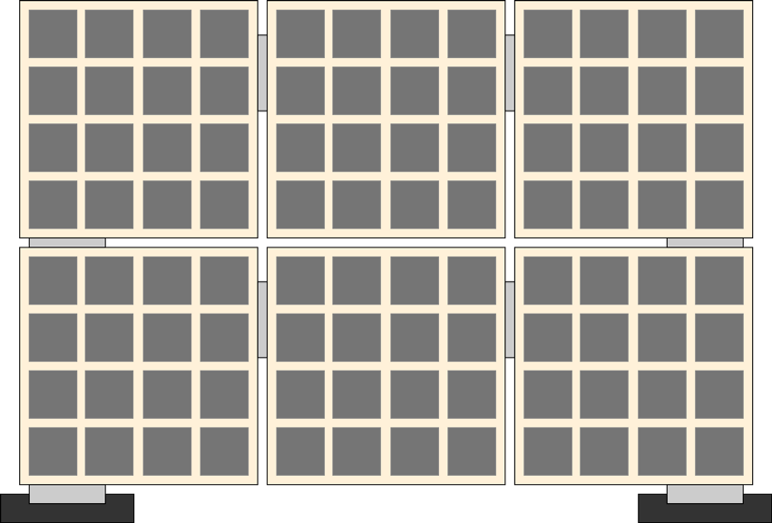

# Power & data setup

Power usage for the wall is as follows (LEDS at full white, running on 5V). The datasheet of the WS2812B states that the maximum current is 60mA for one LED, which comes down to 1500mA per panel. However, the panels never pulled more than 1 amp.

|  |  |  |
| --- | --- | --- |
|  | **Current (amps)** | **Power (watts)** |
| **Display panel** | 1 | 5 |
| **Tile** | 16 | 80 |
| **Wall** | 96 | 480 |

## Wiring of wall (overview)

## Wiring data & power (wall scale)

## Wiring data & power (tile scale)

This is an abstract overview of the data and power wires will be routed on each tile.

Each tile has its own switching power supply and micro controller. The PSU is from Mean-Well and has maximum output of 26 amps at 5 volts. The micro controller is a standard ESP32-S3 DevKitC N16R8, which gets powered from the PSU.

* Mean-well 26A 5V switching power supply: <https://www.tinytronics.nl/shop/en/power/power-supplies/5v/mean-well-power-supply-5v-26a-switching-power-supply-rs-150-5>
* ESP32-S3 DevKitC N16R8: https://www.bitsandparts.nl/ESP32-S3-DevKitC-N16R8-Ontwikkelboard-WiFi-Buetooth-p1923999

All electrical components of the tile, excluding the display panels themselves, are in a shielded box. The box has an outward facing female Powercon connector and a USB-B port for UART from the Raspberry pi to the ESP32S3 (display driver).

